ASSIGNMENT :4

TEAM ID: PNT2022TMID50420 NAME: M.MUNEES WARAN

REG N0: 952319205029

# CODE:

#include <WiFi.h> #include <PubSubClient.h> WiFiClient;

#define ORG "nhpwjc"

#define DEVICE_TYPE "NodeMCU" #define DEVICE_ID "USE YOUR ID" #define TOKEN "USE YOUR TOKEN"

#define speed 0.034

char server[] = ORG

".messaging.internetofthings.ibmcloud.com"; char publishTopic[] = "iot-2/evt/Data/fmt/json"; char topic[] = "iot-2/cmd/home/fmt/String"; char authMethod[] = "usetoken- auth"; char token[] = TOKEN; char clientId[] = "d:" ORG ":" DEVICE_TYPE ":" DEVICE_ID; PubSubClient client(server, 1883, wifiClient); void publishData(); const int trigpin=5;

const int echopin=18; String command; String data="";

long

duration; float dist; void setup()

{

**Serial**.begin(115200); pinMode(trigpin, OUTPUT);

pinMode(echopin, INPUT); wifiConnect(); mqttConnect();

} void loop() {

publishData(); delay(500); if (!client.loop()) {

mqttConnect(); } }

void wifiConnect() {

**Serial**.print("Connecting to "); **Serial**.print("Wifi"); WiFi.begin("Wokwi-GUEST", "", 6); while (WiFi.status() != WL_CONNECTED) { delay(500);

**Serial**.print("."); }

**Serial**.print("WiFi connected, IP address: "); **Serial**.println(WiFi.localIP());

}

void mqttConnect() { if (!client.connected()) {

**Serial**.print("Reconnecting MQTT client to "); **Serial**.println(server); while (!client.connect(clientId, authMethod, token)) { **Serial**.print("."); delay(500);

} initManagedDevice();

**Serial**.println(); } }

void initManagedDevice() { if (client.subscribe(topic)) {

// Serial.println(client.subscribe(topic)); **Serial**.println("subscribe to cmd OK");

} else {

**Serial**.println("subscribe to cmd FAILED"); } } void publishData()

{ digitalWrite(trigpin,LOW); digitalWrite(trigpin,HIGH);

|  |  |
| --- | --- |
| delayMicroseconds(10); digitalWrite(trigpin,LOW); duration=pulseIn(echopin,HIGH); dist=duration*speed/2; if(dist<100){ String  payload = "{\"Alert distance\":"; payload += dist; payload += "}";  **Serial**.print("\n");  **Serial**.print("Sending payload: "); **Serial**.println(payload); if (client.publish(publishTopic, (char*) payload.c_str())) **Serial**.println("Publish OK");  } else {  **Serial**.println("Publish FAILED"); } }  } | { |

# CONNECTIONS:

X

# OUTPUT:

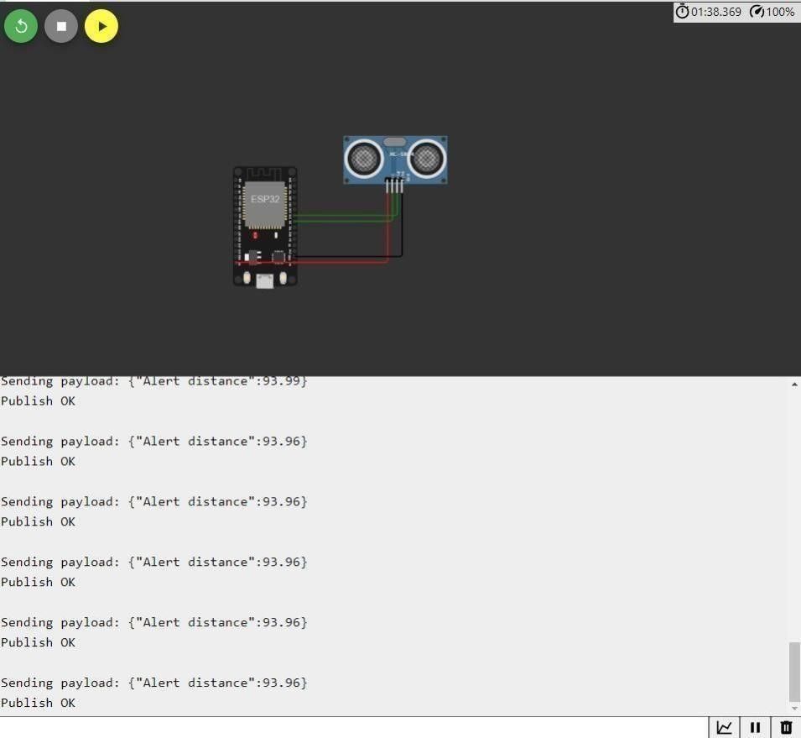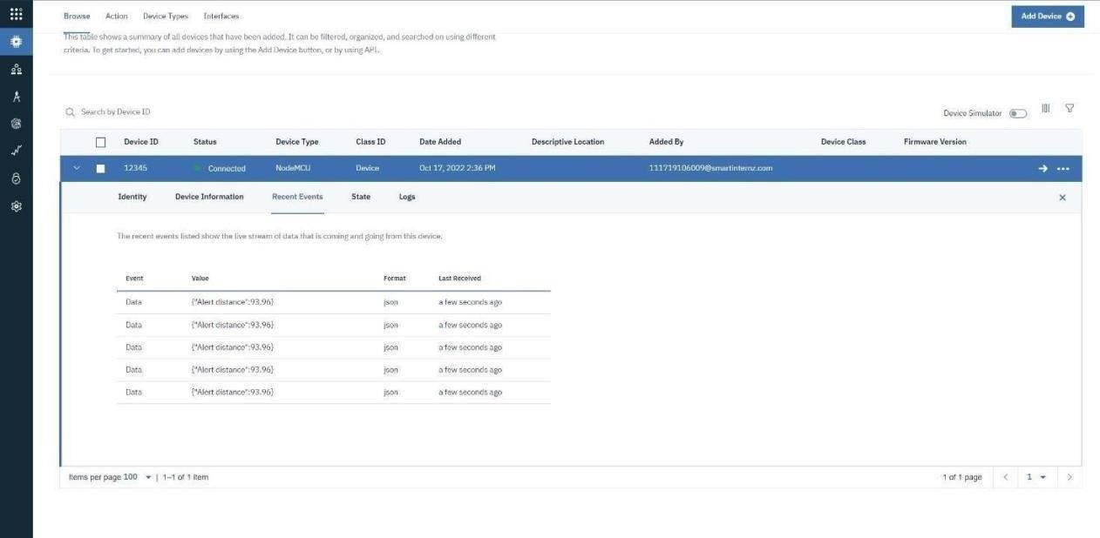

**WOKWI LINK -** [**https://wokwi.com/projects/346405970317935188**](https://wokwi.com/projects/346405970317935188)